**Report for Connected and Autonomous Robotic System**

**Jay Parsana (Individual Report)**

**Task:**

Working on the depth-sensing using the ZED stereo camera. Integrating object detection and UWB localization with ZED camera and depth sensing.

**Installation and documentation:**

1. The ZED camera has an SDK which is available at their website:

<https://download.stereolabs.com/zedsdk/3.1/jp43/jetsons>

1. The Jetpack comes with CUDA preinstalled which is used by the ZED SDK. The ZED SDK does not work without CUDA support. The SDK is based on Nvidia’s CUDA and GPU.
2. The complete documentation for ZED SDK usage and the support for various platforms and packages is available at

<https://www.stereolabs.com/docs/>

**ZED camera calibration:**

1. Initially, I ran the calibration application for the ZED camera. It does not work on the Jetson Nano, so we must use a different PC for calibration. The application can be found in the root/usr/local/zed/ folder
2. Run the application ZED_Calibration file and follow the steps shown on the screen.
3. After the calibration is done, copy the file in the settings folder and paste it in the Jeston nano zed folder which is the same as the above.

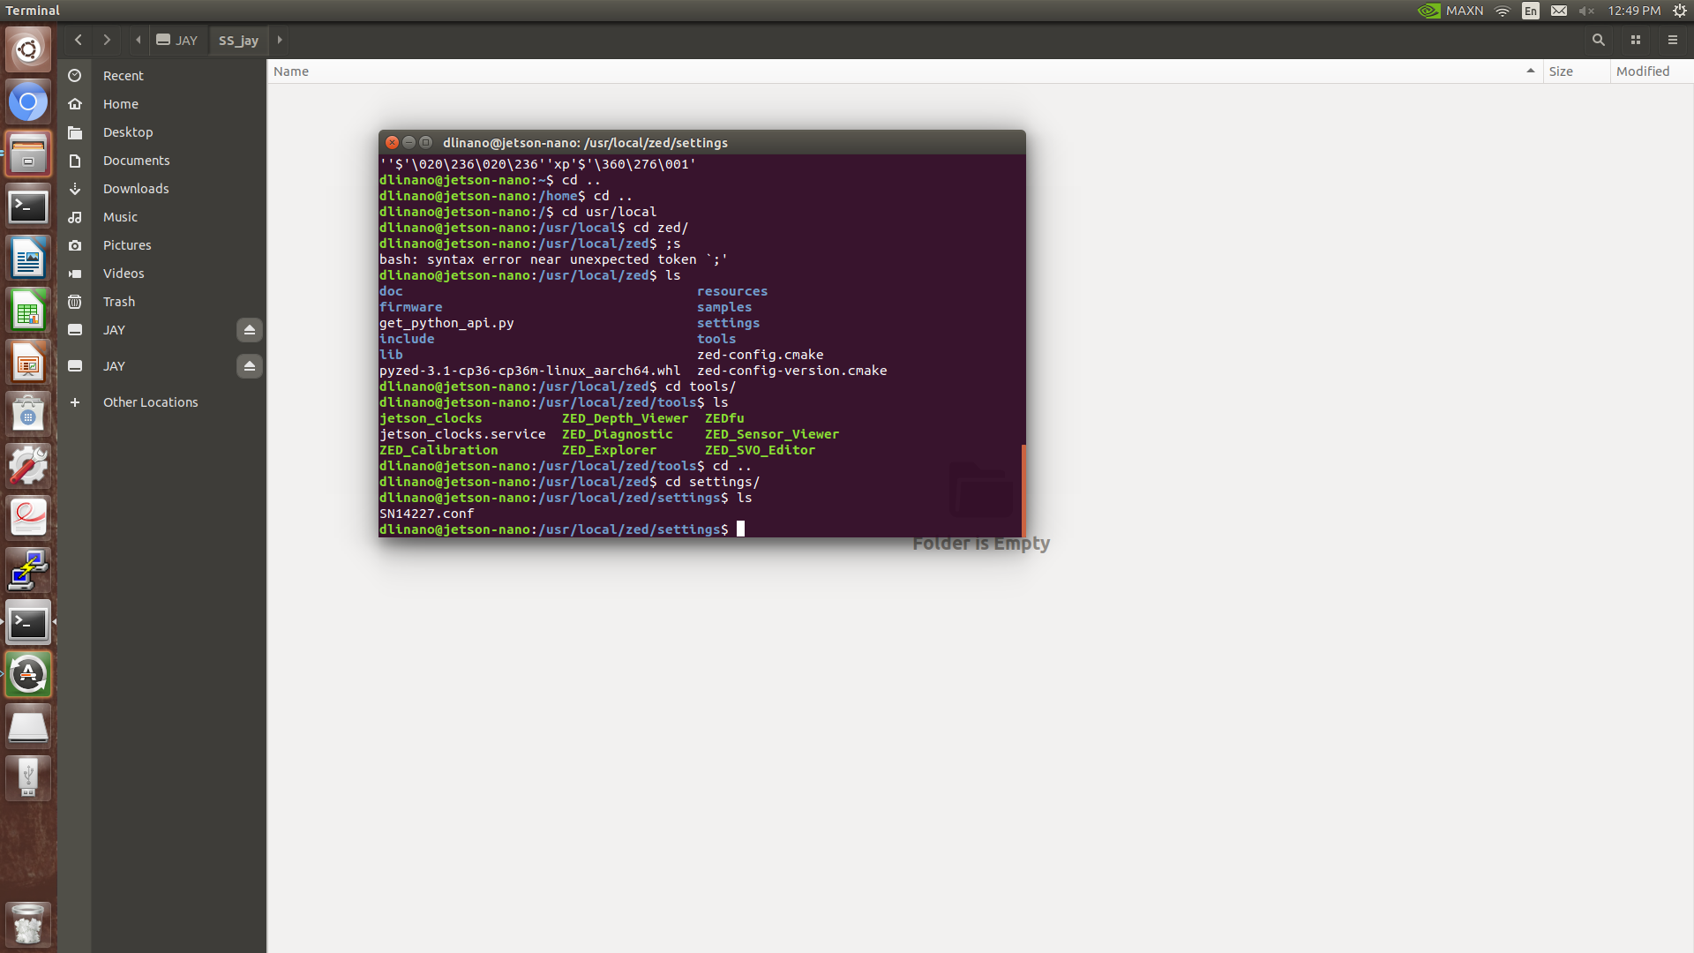

**Running the samples:**

The ZED camera has some samples in the folder ./zed/samples. I ran all the samples and saw what features the SDK provides and which features can be used. The ZED camera SDK supports the Python and C++ languages. We made use of python language for our application.

**Stereo Camera working:**

The ZED camera is a stereo camera i.e. it has two cameras separated by a certain distance called the baseline. The same is true for the human eyes which can perceive depth because of the distance between them and we try to mimic it. If the baseline is small, the depth perception for objects close to the camera would be excellent, but it would be inaccurate for faraway objects. If we keep on increasing the baseline, we could accurately measure the length of the faraway objects (given a camera with good quality image capturing ability) but the minimum distance for capturing the depth information would increase. This happens because the left and right images will capture an object at different positions due to the baseline separation i.e. there would be a shift in pixels. The depth is inversely proportional to the shift in the pixels. Thus, closer objects would appear more shifted and the faraway objects would appear less shifted between the left and right images.

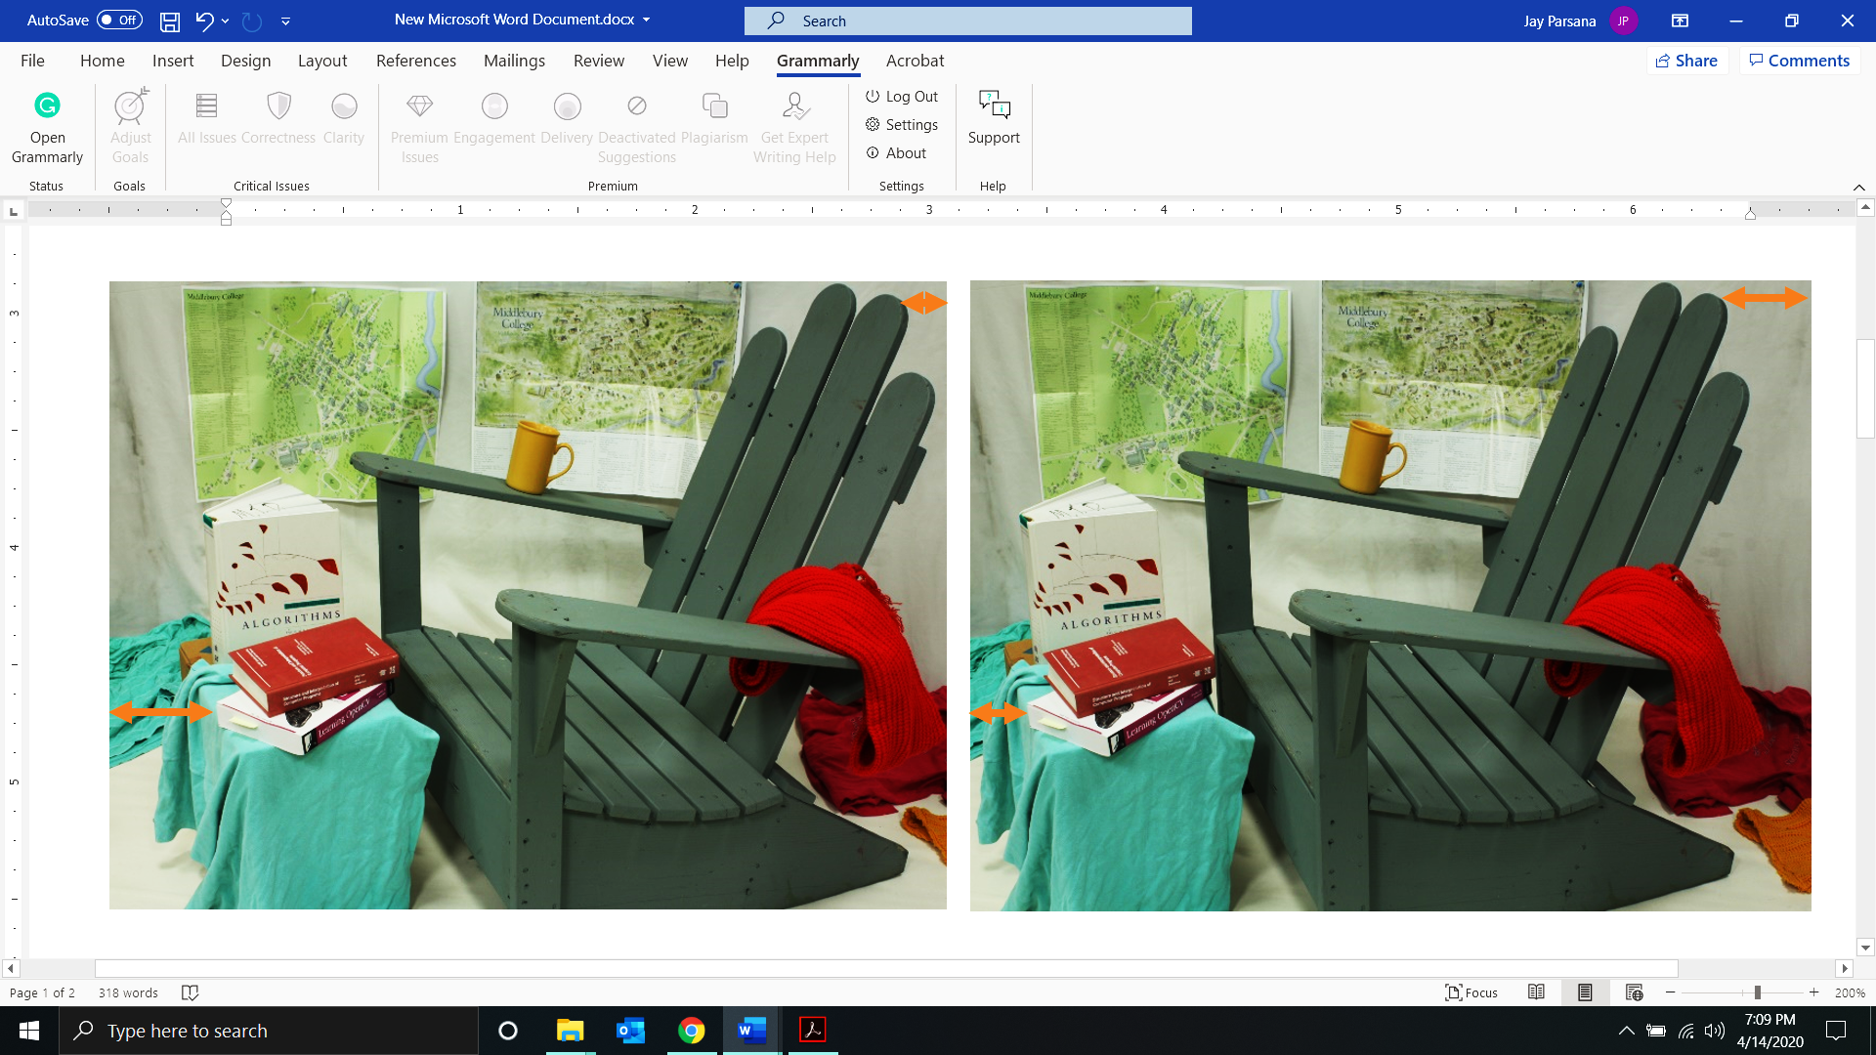

The image above shows the difference between the left and the right image. The block matching algorithm uses this difference to calculate the disparity and then convert it into depth using the extrinsic and intrinsic camera parameters.

**Depth Sensing and integrating object detection:**

The ZED camera has the depth-sensing API’s and point cloud API’s that can be used for getting the depth of the object.

1. The ZED camera has two cameras for calculating the depth estimation. We first capture the images from the left and right cameras.

zed = sl.Camera() #Camera object for accessing the zed camera data

1. The next step is to initialize the camera with proper settings based on our application. (<https://www.stereolabs.com/docs/depth-sensing/depth-settings/>)

# Set configuration parameters

init_parameters = sl.InitParameters()

init_parameters.camera_resolution = sl.RESOLUTION.HD720

init_parameters.depth_mode = sl.DEPTH_MODE.ULTRA

init_parameters.coordinate_units = sl.UNIT.METER

init_parameters.depth_minimum_distance = 0.3

init_parameters.camera_fps = 30

* There are 4 resolution settings for the ZED camera. We choose the HD720 for better performance and higher FPS.

1. HD2K,
2. HD1080
3. HD720
4. VGA

* We make use of the ULTRA mode where the depth of far objects can also be calculated accurately. With the other modes like QUALITY, MEDIUM, and PERFORMANCE the depth information becomes less and less reliable, but the frame rate increases as we go towards PERFORMANCE mode.
* We can measure the depth of the objects in millimeters or meters. We use the setting of the meter for our application.

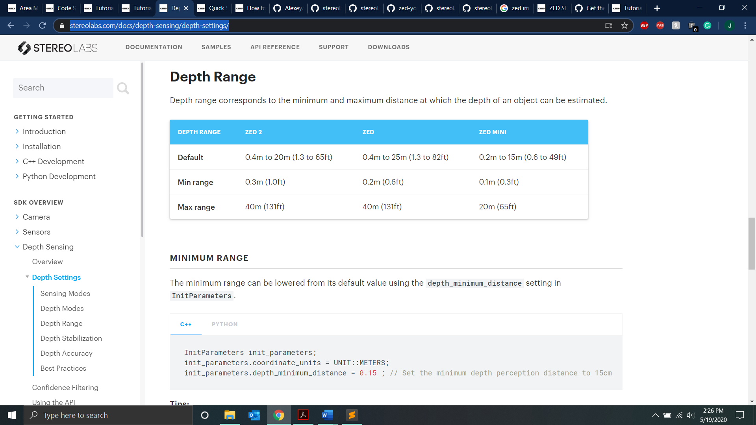

* We choose the minimum distance at 0.3 meters for good performance. As the minimum distance decreases, the FPS drops, and computational power increases.
* The 30 FPS is good enough for our application. Since we are going to overlay object detection, the application won’t be able to utilize the full FPS provided by the SDK.

1. An empty zed image matrix object can be defined by using these methods for storing an image.

# The usual way to define a zed matrix

zed_image = sl.Mat()

# For displaying the depth information, image information, or point cloud # using the OpenCV’s display command.

zed_depth = sl.Mat(zed.get_camera_information().camera_resolution.width,

sl.get_camera_information().camera_resolution.height,

sl.MAT_TYPE.U8_C4)

The zed image matrix consists of float values but the OpenCV uses only 8-bit data to represent a pixel. So we normalize the data to 0 to 255 values to represent a pixel.

1. Before every frame grab we check if the camera is still available so that we can grab the left and right images. We use ***sl.RuntimeParameters()***,which has enums for all the error codes to ensure if frame grab was successful.

zed.grab(sl.RuntimeParameters()) == sl.ERROR_CODE.SUCCESS

1. We save the left image because it is the reference image for our object detection.
   * The code to retrieve the left image is:

# Extract the left image for displaying it to the user.

zed.retrieve_image(zed_image,sl.VIEW.LEFT)

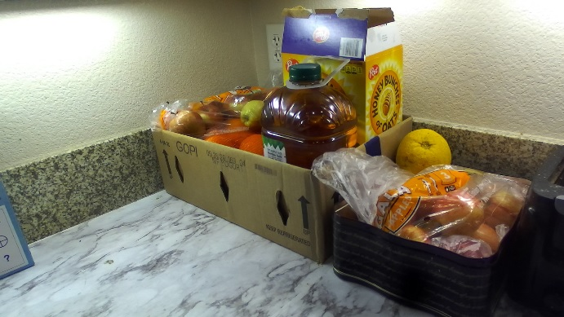

* For the object detection part, we send the left image to the model. But the zed camera uses the zed object to store image whereas the object detection model stores the image into a CUDA capsule so it can process the image using the GPU for better performance.
* We cannot directly convert the ZED image into the CUDA capsule. Based on the ZED website:

[https://www.stereolabs.com/docs/opencv/python/#](https://www.stereolabs.com/docs/opencv/python/)

we convert the image into NumPy array first using the API:

# Retrieve data in a NumPy array with get_data()

image_ocv = image_zed.get_data()

* From the jetson utils website which has several API’s at:

<https://rawgit.com/dusty-nv/jetson-inference/python/docs/html/python/jetson.utils.html>

we can make use of the ***cudaFromNumpy()*** to convert our NumPy array to CUDA capsule using:

cuda_img = jetson.utils.cudaFromNumpy(numpy_img)

* This capsule is then sent to the object detection module and we get back the bounding boxes for the objects in an image.

1. We get the depth retrieval of an image can be found at:

<https://www.stereolabs.com/docs/depth-sensing/using-depth/>

We can get the depth information of the objects using:

zed.retrieve_measure(depth, sl.MEASURE.DEPTH)

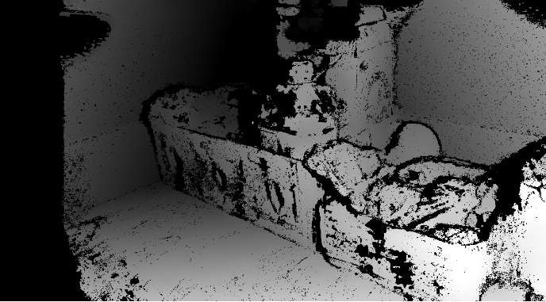

* The depth object in the above code can be used to get the depth of any object using the respective pixel.
* So after getting all the bounding boxes from the object detection module we use the center of the bounding box to get the image coordinate (x, y).
* We feed this image coordinate information (x, y) to get the depth information at that pixel.
* This is used for calculating the depth of all the objects in the image.

1. For the next part, we retrieve the point cloud information of all the pixels w.r.t camera as the origin i.e. (0, 0, 0). The objects coordinate (X, Y, Z) in the real-world is based on the camera as the origin. We can retrieve this information using the API:

zed.retrieveMeasure(point_cloud_img, MEASURE::XYZRGBA)

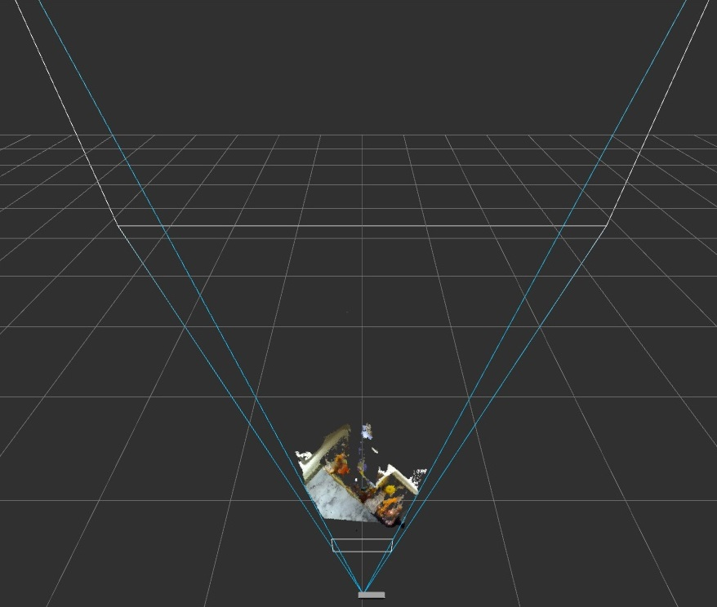

The image above shows the bird’s eye view with the point cloud points marked based on the depth value.

Using the point cloud information, we can calculate the distance of the objects using the formula:

$${distance}_{(x, y, z)}= \sqrt{x^{2}+y^{2}+z^{2}}$$

Note we calculate the distance from the camera which is at (0, 0, 0) to the object.

Based on the image coordinates (x, y, z) and intrinsic cameras sensor parameters such as focal length (fx, fy) and optical center coordinates (cx, cy) we can get the world coordinates for the objects w.r.t the camera. We can get the parameters fx, fy, cx, and cy directly from the ZED camera calibration file. The formula for getting world coordinates is:

$$X= \frac{depth}{fx*(x -cx) }$$

$$Y= \frac{depth}{fy*(y -cy) }$$

$$Z= {depth}_{(x, y)}$$

From the above equations, assuming that the camera is at the location (0, 0, 0) i.e. the origin, we can calculate the location of the object (X, Y, Z).

We get the following results using after integrating the object detection part:



We can see that the objects are being detected and we display the depth to each object measured in meters using the stereo camera.

**Integration of depth sensing and object detection with UWB module:**

The ZED stereo camera and the UWB module are placed together, as shown in the image below. This helps us to localize the camera/drone w.r.t the UWB anchors. We find the location of the objects w.r.t the UWB anchor at (0, 0, 0).

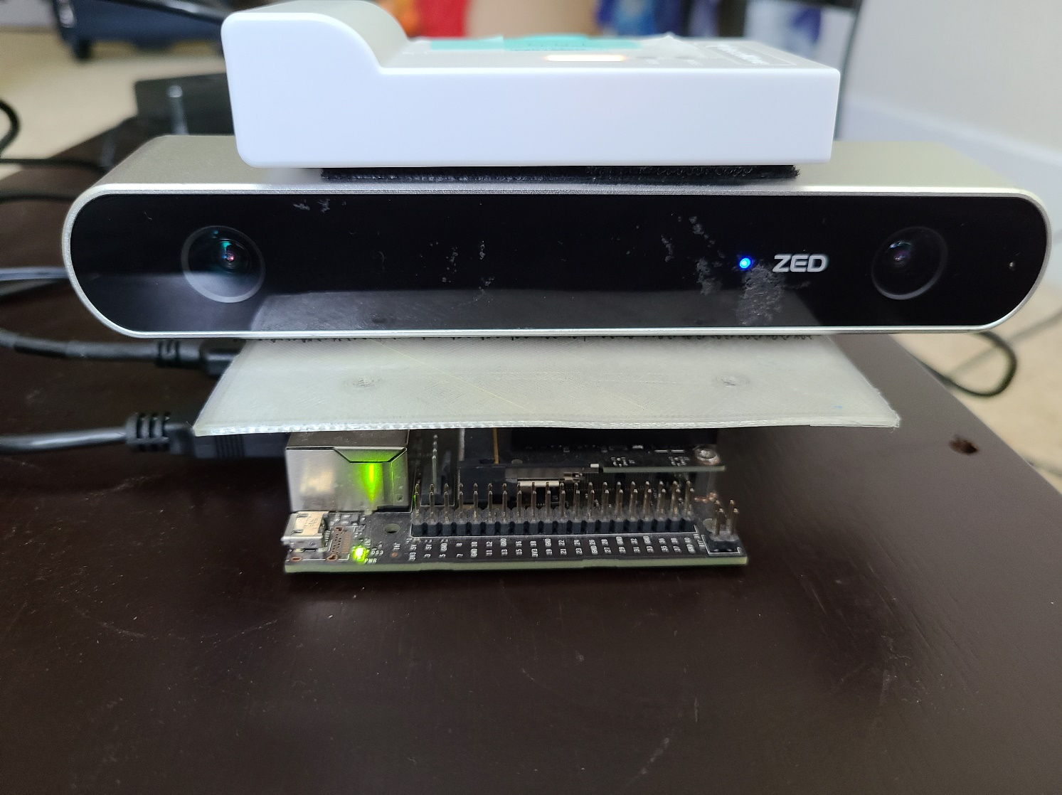

1. After getting the coordinates of the drone from the UWB in an indoor environment, we use that coordinate to calculate the position of the objects detected in the real world.
2. We then obtain the bounding boxes from the detected objects.
3. This information is useful for extracting the objects’ camera-based coordinates, which are then converted to real-world coordinates.
4. The camera is at position (0, 0, 0), and based on camera as origin we get the objects real-world coordinates.
5. We faced some problems with reading the UART and parsing the camera location. It also slowed down our FPS. So we implemented threading to poll the data on the UART every 100 ms (the rate at which the UWB update the tag location).
6. We defined the global variables for storing the coordinates of the camera and updated it every 100ms. This helped us in improving our code and increasing the FPS making our code more stable.
7. Earlier it caused many problems without threading. The program, as well as the system, used to crash if no new data is obtained from the UWB module as the UWB code was in the same loop as the image frame grabbing loop.
8. The threading implementation made the UWB module independent of the depth sensing and object detection part. So even if we miss some data from the UWB module, the program did not crash.

t = Thread(target=modify_variable, args=(serr,zed))

t.start()

Here, ***modify_variable*** is a function, which will be executed as a separated thread and ***t.start()*** will start this thread. We also implemented an event for when we press Ctrl+C, the thread will terminate.

We get the following output after integrating all the modules:



We perform experiments so that we can verify that the object localization is working, and we also find the accuracy of our object localization approach.

1. We measure the ground truth results with the calculated results and take 10 observations.
2. The camera was at a fixed position and the object was moved around inside the room.
3. The flow chart below explains about how the integrated code works to provide us with object localization.

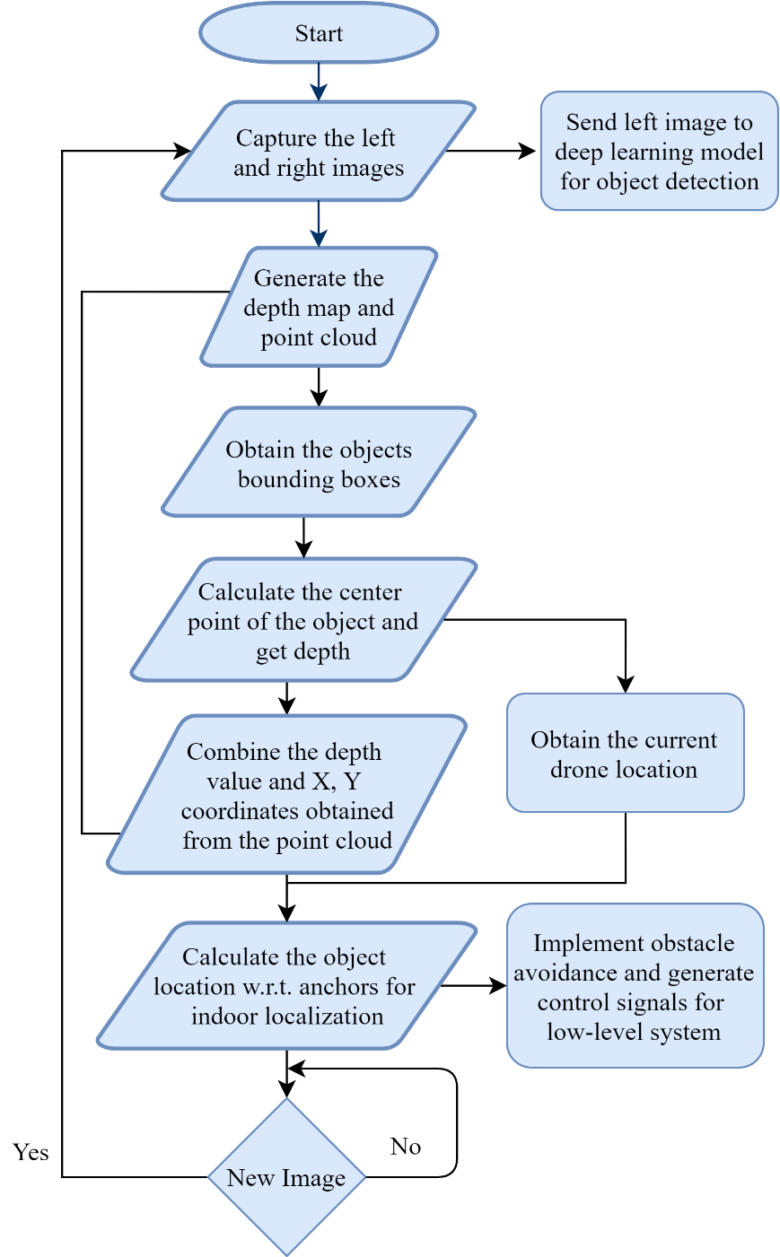

1. We follow the above steps and obtain the center of the object which will be useful in extracting their real-world coordinates directly from the computed point cloud. The concept is shown in Figure below:

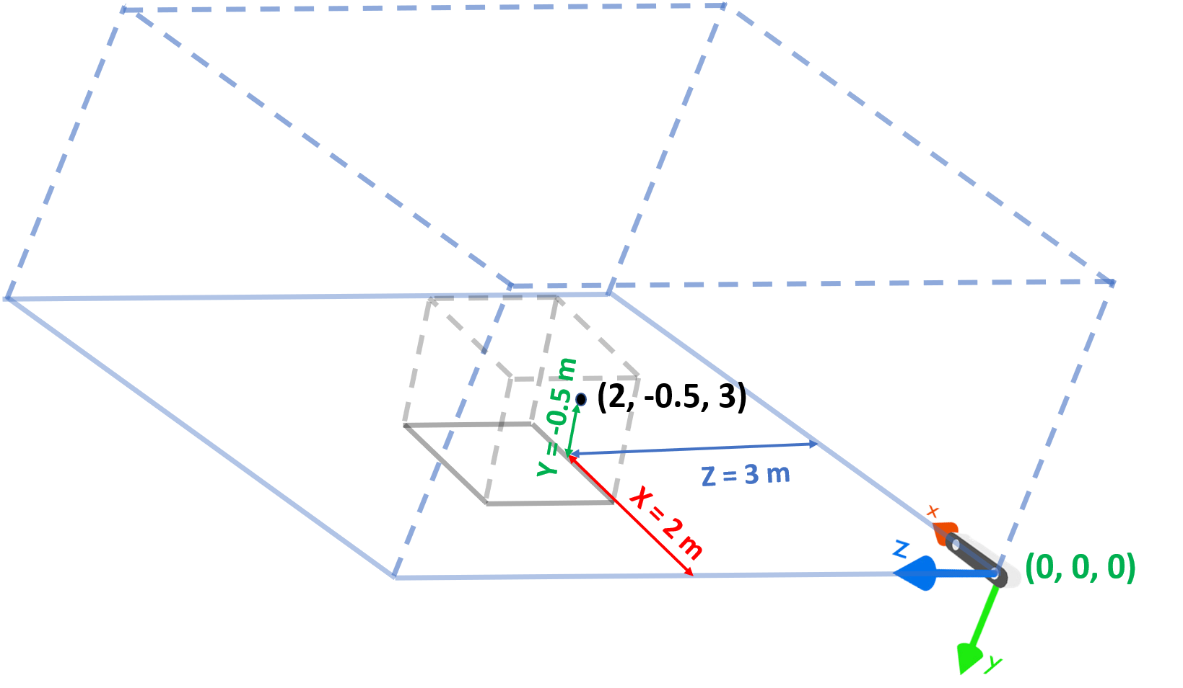

Figure 1

1. Now, we need the object coordinates w.r.t the Anchor 1 shown in fig 1.1 to perform localization. So, we get the camera coordinates mounted with tag from the Anchors placed in the room and add/subtract the actual camera coordinates available from DWM to the location of the object available from the camera.

dwm_to_object_x = (dwm_to_camera x – drone_to_object_x)

dwm_to_object_y = (dwm_to_camera_y + drone_to_object_y)

dwm_to_object_z = (dwm_to_camera_z – drone_to_object_x)

1. Through our calculations shown above, we get the object (X, Y, Z) as (-0.44, 2.1, -1.11) w.r.t DWM module as per fig 1 i.e. we achieve object localization.
2. The figure below shows how the setup was done inside the room and the results of the experimentation.

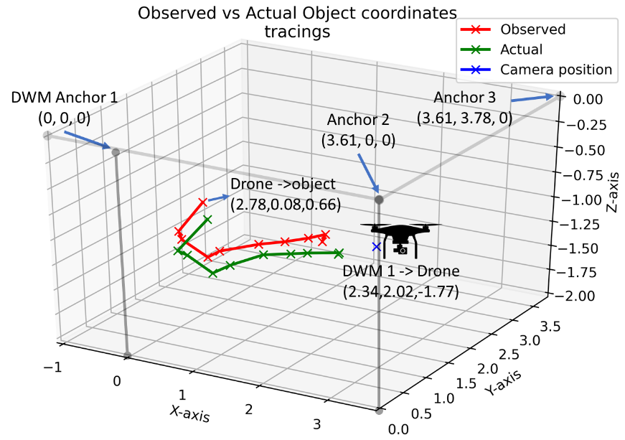

Fig 1.1

1. The 3D plot in Fig. 1.1 mimics the actual set up that we used for evaluation. The 3 anchors and drone attached with tag (blue ‘x’ mark) were placed with the coordinates shown. The calculated coordinates are shown with the red line and the ground truth is shown with a green line. As we can see the error between them is less.
2. To visualize the error more prominently, we calculated the Euclidean distance and plotted them in Fig. 2. We can see that the ground-truth line and the calculated line match very closely in the graph based on the object’s location.
3. To emphasize the accuracy, we calculated the error percentages for the difference in the Euclidean distance for each observation and plotted it as shown in Fig. 3

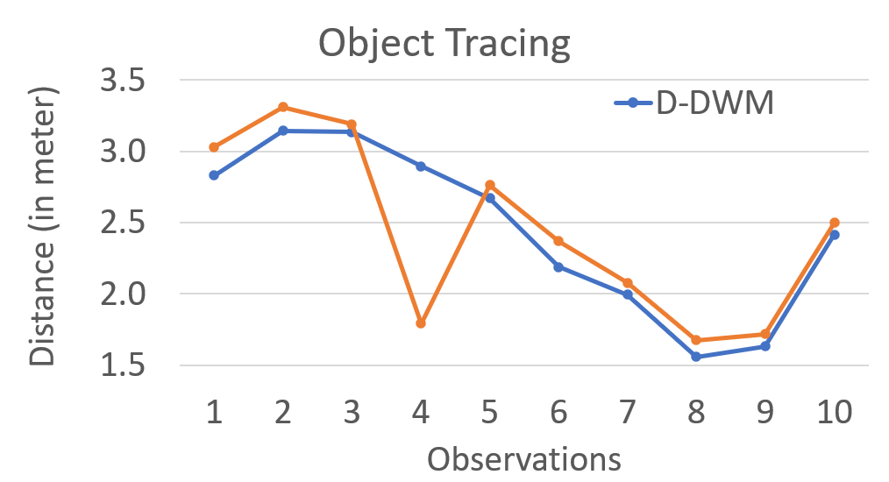

Fig 2

1. The error rate Fig. 2. Ground truth distance vs calculated distance. Fig. 3. Distance error rate for the experimental setup. is well in the range of 1.81% to 8.45%. The average error rate for the 10 observations comes out to be 8.45%.

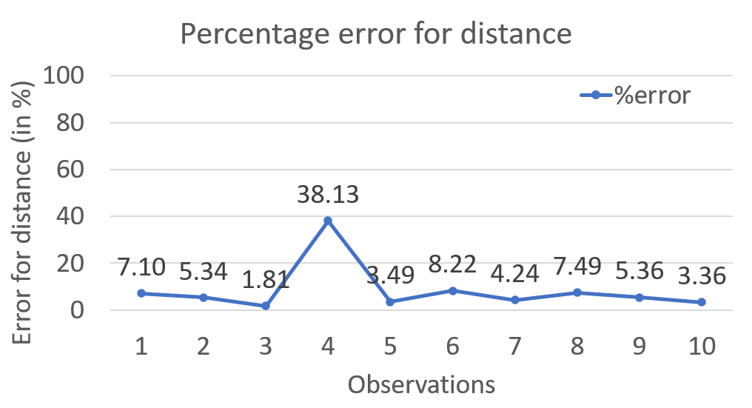

Fig 3

* For the above experiment we keep the camera stationary and change the position of the object and take the readings one by one. We take the calculated value of X, Y, Z and then we measure the ground truth using a measuring tape and we get the ground truth X, Y, Z for the detected object. The plotting code and the excel sheet is attached in the drive folder.
* We now keep the objects stationary and change the camera position in linear form and see whether the objects location is stationary or not w.r.t the UWB anchor. The plot in fig 4 show the linear motion of the camera.

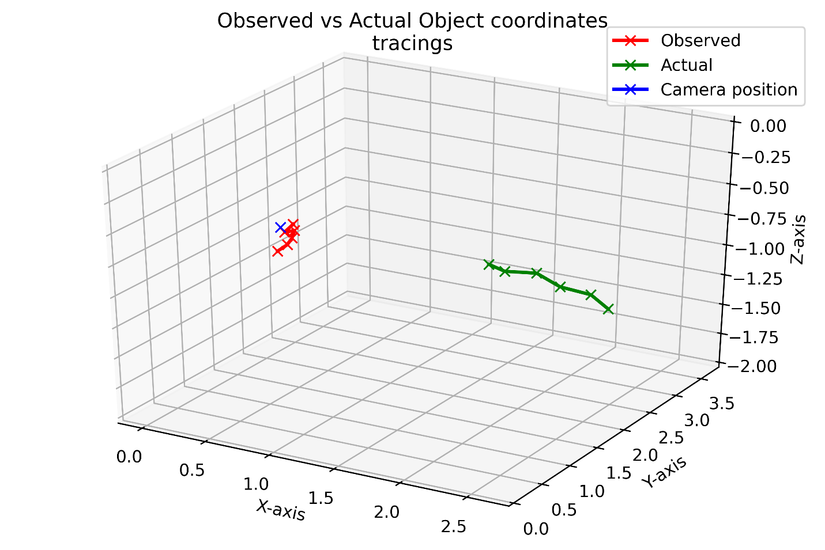

Camera /drone linear motion

Object stationary location

* The green marker shows the linear movement of the camera. The red marker shows the object location which should be stationary after moving the camera each time by about 20cm for 6 consecutive readings.
* The blue marker shows the ground truth location of the object w.r.t to the UWB. As we can see, the object location is quite the same even after we move the camera by about 1.2 meters in total.
* Thus, we prove that the object localization is achieved by conducting the above experiment. The excel sheet with the name object_localization_linera_motion.xlxs has the details of the object localization and plotting_linear_motion_trace.ipynb has the plotting code.